- PROBLEM STATEMENT
The objective of this project is to analyse a given image and extract meaningful colour-based insights.
This includes identifying the dominant colour, generating a colour palette using clustering, calculating HSV statistics, visualising the RGB distribution, and presenting all results in a combined graphical dashboard.
The goal is to help designers, photographers, and developers understand the colour composition of an image efficiently.

- APPROACH/METHODOLOGY DATA STRUCTURE USED

    - Read the input image and preprocess it by resizing for faster computation.

    - Convert the image between BGR, RGB, and HSV colour spaces for different analysis tasks.

    - Determine the dominant colour using a frequency counter.

    - Use K-Means clustering to generate a 5-colour palette.

    - Compute mean Hue, Saturation, and Value from the HSV image.

    - Plot RGB intensity histograms to understand brightness and distribution.
    - Display all results (image, palette, histogram, colour swatches, and calculated metrics) in a clear visual layout.

Data Structures Used
- NumPy Arrays – for image matrices, reshaping, and mathematical operations.
- Python Dictionary – to compute the closest CSS colour name.
- Counter (from collections) – to find the most frequent RGB colour.
- KMeans (sklearn) – to create a 5-cluster colour palette

3. SAMPLE INPUT OUTPUT
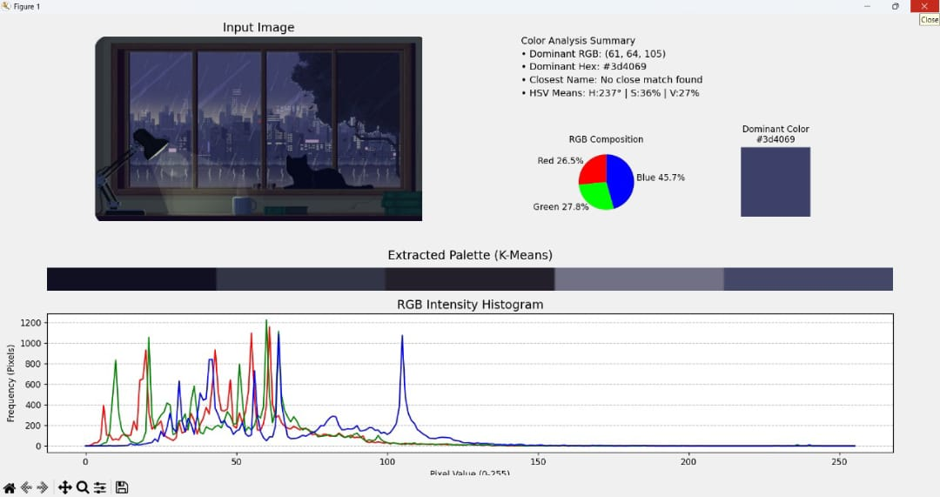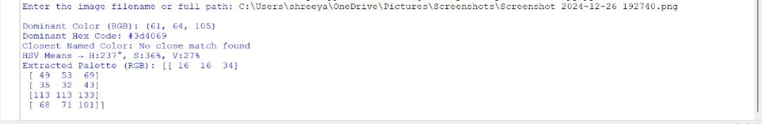
- Challenges Faced

- Handling incorrect or invalid image paths given by the user.
- Managing BGR vs RGB confusion due to OpenCV using BGR format.
- Accurately converting arbitrary RGB values to the closest CSS3 color name.
- Balancing runtime while processing large images → solved by resizing.

- APPROACH/METHODOLOGY DATA STRUCTURE USED

    - Read the input image and preprocess it by resizing for faster computation.
    - Convert the image between BGR, RGB, and HSV colour spaces for different analysis tasks.
    - Determine the dominant colour using a frequency counter.
    - Use K-Means clustering to generate a 5-colour palette.
    - Compute mean Hue, Saturation, and Value from the HSV image.
    - Plot RGB intensity histograms to understand brightness and distribution.
    - Display all results (image, palette, histogram, colour swatches, and calculated metrics) in a clear visual layout.

5. SCOPE FOR IMPROVEMENT

- Add an option to save output plots as image files.
- Integrate GUI using Tkinter or PyQt for easier usage.
- Add support for extracting the top N dominant colours instead of only one.
- Improve the closest colour matching using CIEDE2000 instead of Euclidean RGB distance.
- Allow users to choose different clustering algorithms (Mean-Shift, DBSCAN).
- Add contrast, brightness, and saturation analysis.
6. SCREEN SHORTS OF THE EXECUTABLE CODE WITH OUTPUT

